

## 

**Classroom Implementation of the Panorama School Climate and Culture Survey**

* + **Date: March 4-8, 2024**—The day can be selected by the teacher or school.
  + **Grades 3-12 Student Survey—**Students will log in to [surveys.panoramaed.com/wtps](https://surveys.panoramaed.com/wtps/login) using their **Student ID (provided in the email)**  as the access code (you may post this link on your Schoology site for easier student access). Teachers do not need to log in but may use the links below to read the questions as needed:
    - **Grades 3-5:** **Homeroom (or Health) Teacher:** [**Grades 3-5 Student Survey**](https://surveys.panoramaed.com/wtps/demo/7d32443c-04dd-4e17-886c-f4a1cae0e30e) , 29 questions/10 minutes
    - **Grades 6-12: Health and Physical Education**: [**Grades 6-12 Student Survey**](https://surveys.panoramaed.com/wtps/demo/9a7c69a7-706c-47de-b5d2-28a68fd9b682) ,24 questions/10 minutes
    - Have students click the **blue submit button** at the end to save their survey results.

## Parental Approval

* + **Students With Parent Approval Spreadsheet:** You are provided with a list of students whose parents have consented to them taking the survey
  + **Students Without Parent Approval** should not be givenaccess to Panorama

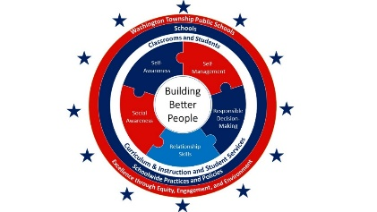

## Helpful Information

* + [Panorama Education Website](https://www.panoramaed.com/social-emotional-learning-sel)
  + Student Survey Proctor Guide
  + [Vocabulary Mini-Lesson](https://docs.google.com/presentation/d/11AEBFcvNM3mw20RKLVYnzFDkQFuAdl8X1FaZyFlzGKA/edit#slide%3Did.p1)